What’s My Line? My Name: ________________________________________
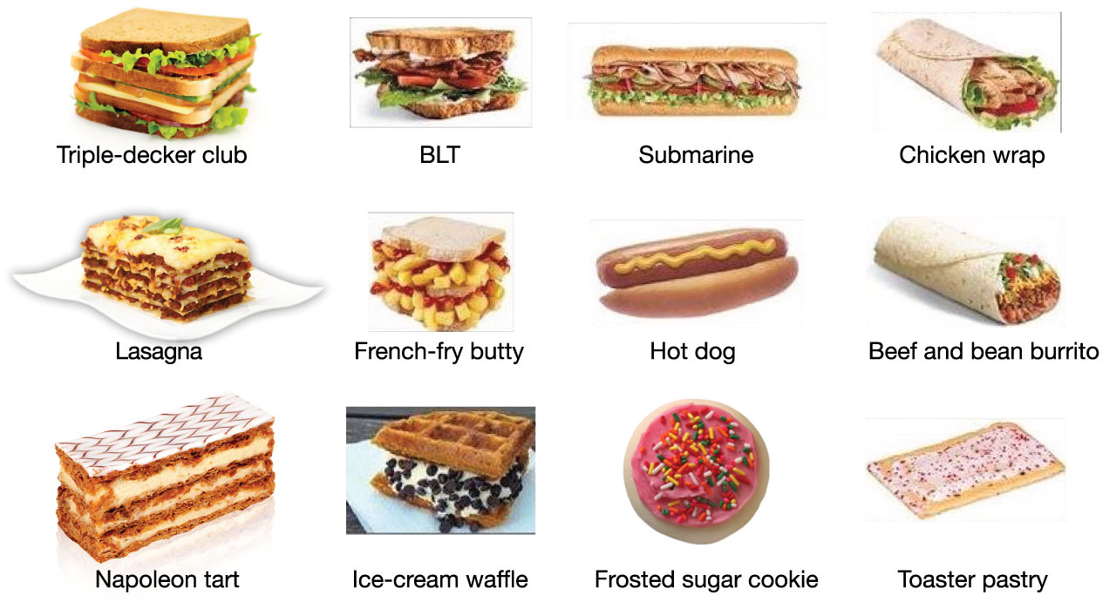
Directions: Is it a sandwich? Review the twelve food items below. Draw a single, unbroken line or curve that divides the sandwiches on one side from the not-sandwiches on the other. Don’t overthink — go with your gut.
Respond to #1–3 on the bottom of this page first.
Your partner will respond to #4–6.
Partner’s Name:

- Based on where the line above is drawn, this person probably also considers
to be a sandwich, and not a sandwich. (Give two new examples.)
- I think this person’s definition is:
A food item is a sandwich if it…
.
- Their definition is absurd! If you believe it, then you’d have to believe is / is not
a sandwich. (Circle one, and fill in the blank with your best argument against their definition.)

Fold here after completing #1–3
- Based on where I drew my line, I would probably consider a sandwich,
and consider not to be a sandwich. (Give two new examples.)
- Based on where I drew my line, what are my beliefs about what makes a sandwich, a sandwich?
Complete this sentence so that anybody who reads it will know exactly where you drew your line:
A food item is a sandwich if it…
.
- Fold on the dashed line above to hide your responses to #1–2. Find a partner whose dividing line is drawn in a different place than yours (so that you disagree on which of these are sandwiches).

